Trauma as the Pre-condition and Consequence of Prostitution.

Dr. Ingeborg Kraus , Edmonton 16.09.2016.

Thank you for inviting me here to Edmonton, especially to Kate Quinn from cease.

So as you heard, I come from Germany, a country that traumatized the entire world during the second world war, and here I am today to talk to you about trauma. And concerning the handling of prostitution, Germany is not at all a role model, in fact it´s hell on earth. And nobody seems to care, especially women. They don´t raise their voice. They shut up.

So first of all I was asking myself: was it a mistake to invite me? An error? Weren't you paying attention at the moment when you invited me?

When we talk about trauma, we have to understand the dynamics of trauma. And one of them is to keep silent, so shut up about what has been done to someone. When we talk about trauma, we also have to think how trauma and collective trauma affects our community. I will give you a couple of examples:

Germany, under the Nazis, attacked, deported, killed, put in concentration camps. And for these crimes, it wasn't the men, but the German women who had to pay. When the liberating soldiers came into Germany, they massively raped the women. Not only the Russian soldiers in Berlin, no, all over Germany, women were raped. And at home, they very often got beaten up by their husbands. They were not allowed to talk about it, they had to shut up and suppress their pain. This mental process: to deny trauma and repress pain, has been well trained by the Germans and seems to have been passed from one generation to the other. If you don´t overcome a trauma, it will be realized again, as Janet already said 100 years ago. So I am asking myself if this silence towards prostitution has something to do with our history. Women have been raped, and they had to keep silent. Now, their men rape, and they keep silent again.

Second, we have a long history of patriarchy. To legitimize the domination and exploitation of women and children without feeling guilt, it is necessary to deny the harm.
When you look at this through the history of psychotraumatology, it started actually with the denial of trauma. Freud, who is the founder of psychoanalysis, treated women (called at that time “hysterical women”). He found out that they were all sexually abused in their childhood. When the men from the medical chamber from Vienna heard about that, they put pressure on Freud and he had to change his thesis. So he developed the fantasy theory were he denied the reality and said that in fact all those women dreamt of the abuse, that they wished it, that this was merely wishful thinking. So again: keep silent!

When Bowelby and Ainsworth found out that the children with a disorganized attachment behavior had experienced neglect and / or sexual violence, they were cut off funding. When the feminists in the 70 said that women who have experienced domestic violence have the same symptoms as the Vietnam soldiers, they were told that rape doesn´t exist in marriage, it´s not trauma. Again: keep silent! Today, when we say that prostitution is violence and causes severe trauma, we get to hear “no, it´s their choice, it´s a sexual service, it´s a job”. So again: a denial of trauma and the order to shut up. Why? All this to protect a taboo subject: male sexuality and its alleged right to fulfilment without constraints or limits.

Healing a trauma means to put words on what has been hidden, to uncover lies. And this is what I did: I put words on the silence. If we want to reverse trauma, we have to tell the truth. So I am not here by chance, but because I have done everything possible to break the silence, which is in my opinion a symptom of a society that has perpetrator introjections. I started with an appeal in my hometown, then I mobilized the German trauma experts to take position, I started a world wide petition in 6 languages addressed to Angela Merkel to abolish prostitution.

This is also an important message to you: Don´t keep silent, raise your voice, because if we keep silent, we become part of the perpetrator´s system and dishonor the victims.

I will try to explain you how prostitution is seen from the point of view of psychotraumatology.

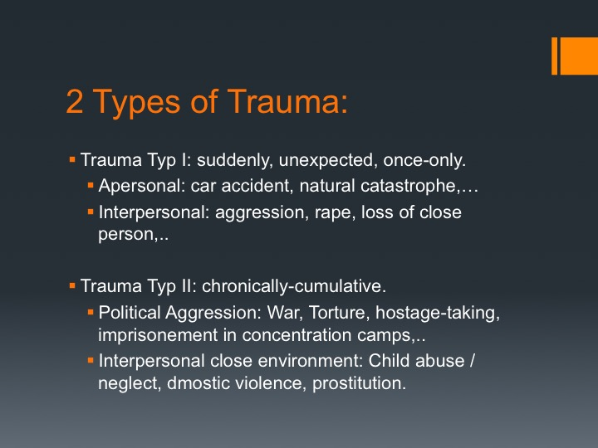

You have 2 types of trauma: The last one causes complex trauma.

When we look at the epidemiology of trauma, we find that it depends on the type of trauma whether you develop PTSD or not. And rape is the highest risk to develop PTSD. So the first lesson to learn is: you can not so easily split off your mind from your body.

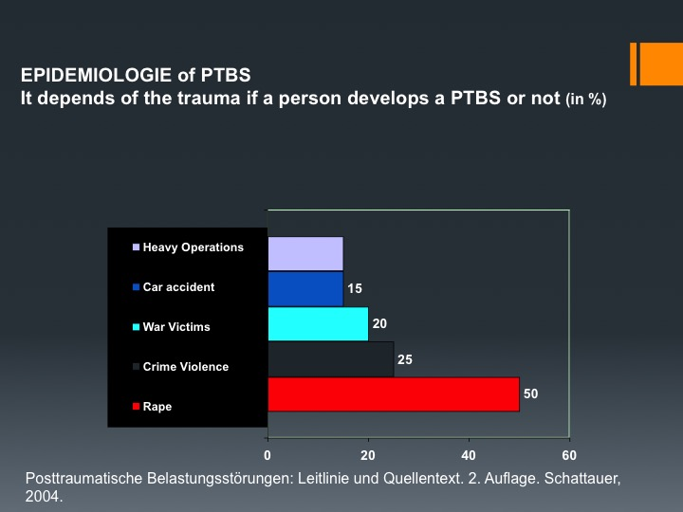

When we look at the prevalence of sexual violence, and thus the worst form of trauma, we must state that it is widely spread. On a global level: 20% of the girls experience sexual violence, 5 to 10% of the boys. A national research done in 2014 in France finds the same number. Children are the most frequent victims of sexual violence. There is a high rate of re-victimization (70% of them will again become victims of sexual violence as adults). The perpetrator comes from the close environment. Those who should care are the aggressors. Those who should be trustworthy, abuse.

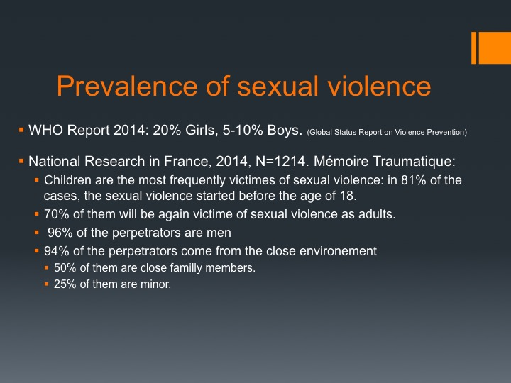
Muriel Salmona, a psychiatrist from France, asked me to come to Paris last year, to talk about the situation in Germany and we found, that we have the same statistics. In Germany, this is the research done by Monika Schröttle and published in 2004, with 10.264 women, aged between 16 and 25.

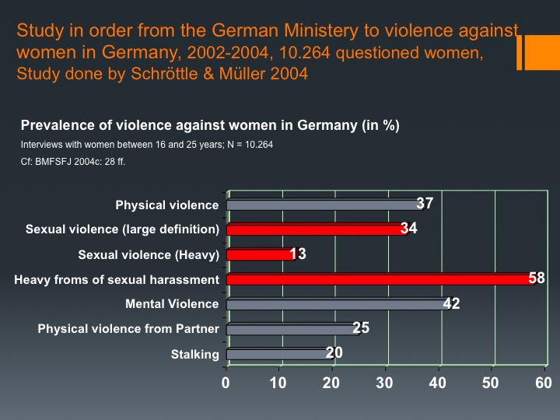

Harm that causes complex trauma is a national problem and costs the society billions of Euros. Van der Kolk, who is the Medical Director of the Trauma Center Research in Brooklin/Massachussets, says: when soldiers come back from war, the newspapers are full of it, when women become victims of domestic violence, nobody cares. Muriel Salmona says that we still live in a culture of rape.

First lesson to learn: This is not about two separate groups in society, i.e. the group of “happy sexworkers” on the one hand, and the group of children who experienced abuse on the other. No, this is one and the same group. It is the children who were abandoned by society then and who are again being abandoned by society now. The prostitution system uses these traumatised children for its own ends.

So what about prostitution? Is prostitution violence? Or a service?

There has been a huge number of research trying to figure out if women in prostitution face violence. Here again the results of the study done by Schröttle in 2004. At that time the majority of the women in prostitution were German (80%). By seeing these numbers you can not say that it´s a job like any other: 92% experienced sexual harassment, nearly 90% physical violence and mental violence and 59% sexual violence. Today the figures would be even worse, I would say 100% of everything, because we have only 5% of German women working in prostitution and 95% are from abroad. The conditions have got worse.

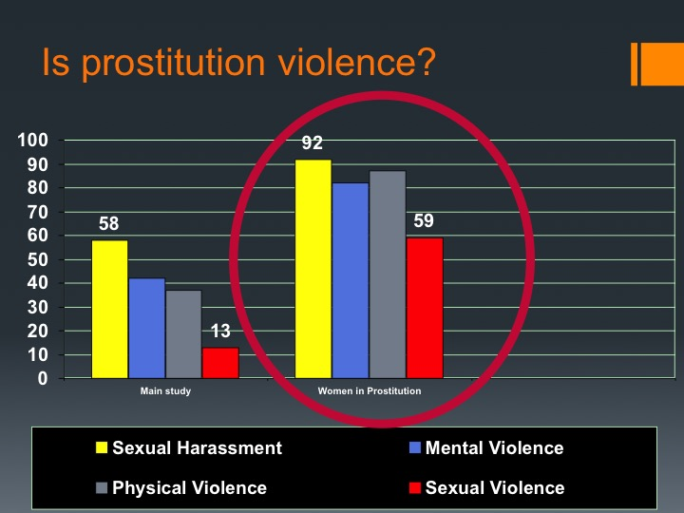

Since the law in 2002, that made prostitution a job like any other, you see growing perversions among sex buyers in Germany. Practices are becoming more dangerous with an increase in violence against women and a lack of protection for the women. There is a “menu” circulating on the Internet, where buyers can choose what they want from a long à la carte list. I will just cite a couple of them:

AF = Algierfranzösisch (Zungenanal) – tongue anal
AFF = Analer Faustfick (die ganze Hand im Hintereingang) – Anal Fist Fucking
AO = alles ohne Gummi – everything without rubber
Braun-weiß = Spiele mit Scheiße und Sperma – play with shit and sperm
DP = Doppelpack (Sex mit 2 Frauen) oder (2 Männer in einer Frau) – Sex with 2 women or double penetration (2 men in one woman)
EL = Eierlecken – licking the balls
FFT = Faustfick total – Fist Fuck totally
FP = Französisch pur (Blasen ohne Gummi und ohne Aufnahme) – blow job without rubber
FT = Französisch total doppeldeutig: Blasen ohne Gummi mit Spermaschlucken und seltener: Blasen ohne Gummi bis zum Finale, aber ohne Schlucken – Blow job without condom and with swallowing the sperm.
GB = Gesichtsbesamung (manchmal auch Gangbang, also Gruppensex) - Ejaculating into the face.
GS = Gruppensex – Group Sex.
Kvp = Kaviar Passiv (Frau lässt sich anscheißen) – Man shits on woman
SW = Sandwich, eine Frau zwischen zwei Männern – one woman between 2 men
tbl, = tabulos, ALLES ist erlaubt – without taboo, everything permitted.
ZA = Zungenanal (am / im Hintereingang lecken) – licking the anus.

So when you read this, I don´t need another study to analyse if prostitution is a service or not. Licking the anus of a stranger is not a job. We have to stop the denial.

How can a woman stand this? And this is the question we have to ask ourselves.

This is what the German trauma expert Michaela Huber says:
- “To allow strangers to penetrate one’s body, it is necessary to extinguish some natural phenomena: fear, shame, disgust, strangeness, contempt and self-blame.
- In their place these women put indifference, neutrality, a functional conception of penetration, a reinterpretation of this act as a “job” or “service”.
- Most of the women in prostitution have learned, through sexual violence or neglect in their childhood, to switch themselves off.

So when we look now at the pre-condition for entering prostitution, we must realize that the majority of women have experienced severe forms of violence in their childhoods.
There are 3 studies: One by Melissa Farley, the other two from German research institutions. We see that sexual violence and physical violence is very dominant.

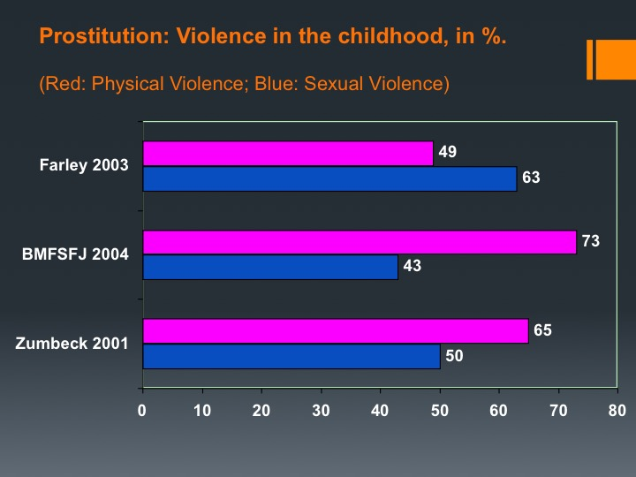

So what does trauma do with a person?

This is a sentence I remembered a couple of years ago when this women who survived 9/11 was invited on the German TV:

„I needed 10 years to understand that I was a survivor and not a victim anymore.”
She went home and she washed herself, she got rid of the dust on her skin, but there was something in her brain that she couldn´t get rid of. In fact she developed Post Traumatic Stress Disorder.

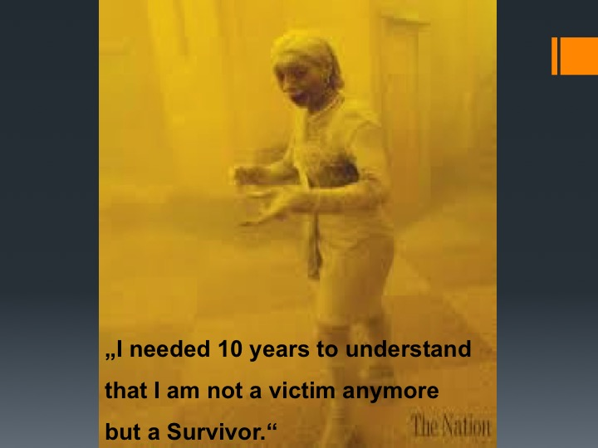

Studies have shown that PTSD is very current among women in prostitution. That´s why I want to first explain to you what simple PTSD is.

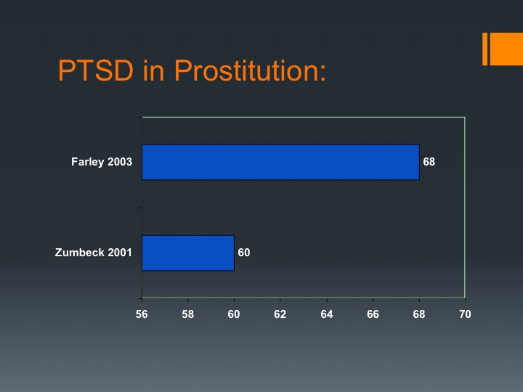
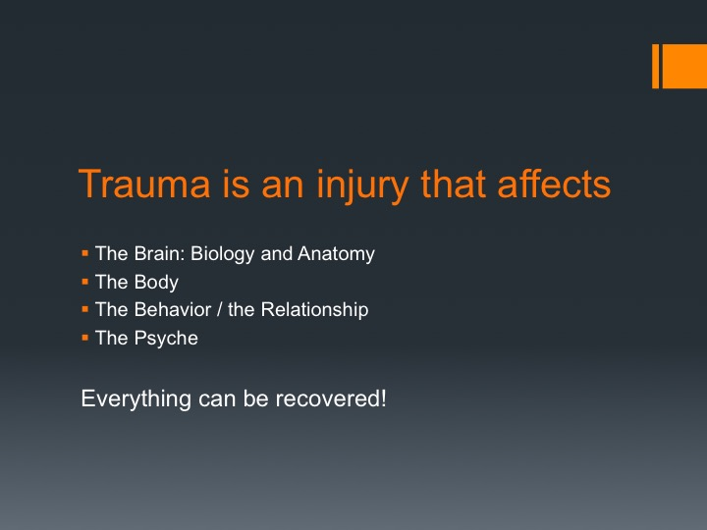

Trauma is an injury that affects:

- The Brain: Biology and Anatomy
- The Body
- The Behavior / Relationships
- The Psyche

I want to introduce you first to the neurobiology of trauma:

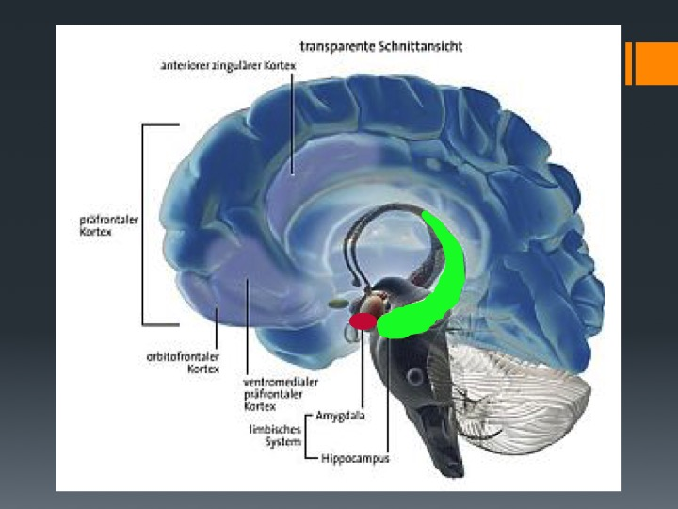
Here are the parts of the brain who are involved in trauma:
- The prefrontal cortex
- The “old brain”
- The limbic system with the amygdala and the hippocampus.

The prefrontal cortex has the capacity to understand and to be in a situation, try to make decisions, remember the past, react, calm down.

The “old brain” has the primitive functions: it´s our autonomic nervous system that will activate our organs to keep us alive. It will make our hart beat faster, our breathing faster, etc.

The amygdala is our alarm system, it has 2 functions:
- It is constandly scanning our surroundings if something wants to kill us and if we are in danger, it produces hormones that put us in a situation that enable us to survive, it´s the “fight or flight reaction”.
- It is also a memory, as we need to remember what was dangerous for us.

The hippocampus is the memory maker. So when information comes in, it will organize it, group it and store it.

So if someone is under heavy distress, the amygdala fires off and sends messages (to glands) in our body that produce hormones to put us in a situation so that we can fight or flight or freeze:

There are 4 hormones that are involved in that:
- Adrenaline that puts our body in a condition to fight back to keep us alive or to flee.
- Cortisol, that gives us the energy in order to execute the fight/flight reaction.

And 2 hormones to block the pain:
- Opioids, which are natural morphines, they protect us from pain, but they block all other emotions also. So sometimes it can happen that women who get raped and talk about what happened to them, say this without emotions.
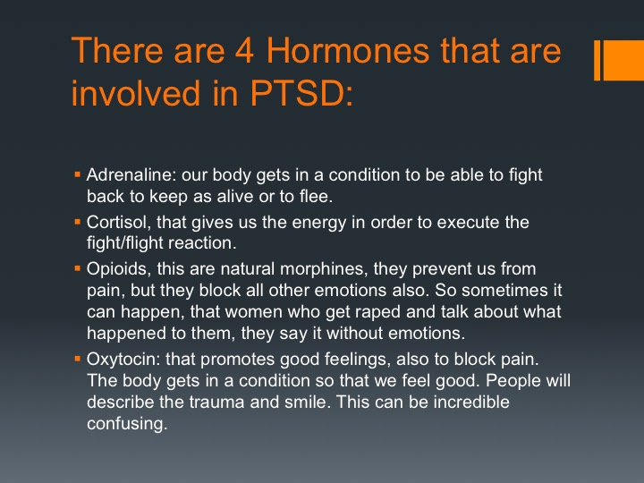
- Oxytocin: that promotes good feelings, also to block pain. The body gets in a condition that we feel good. People will describe the trauma and smile. This can be incredibly confusing and can perhaps also explain the high rate of re-victimization. Prostitution can be a self destructive behaviour to reduce inside pain.

So victims of trauma will have a mixture of a combination of those hormones. It can go up and down, etc. But when you are in danger and you can not flee, the hormone concentration make us freeze. The prefrontal cortex gets flooded by the cathecholomines and we can not make a decision anymore. You know what is happening but you can not stop it, you dissociate.

Here you can see the 2 reactions and what it is doing with us:

- Fight/ Flight Reaktion:
  - Heart is beating faster, blood pressure increases,
  - Fast breathing,
  - Sweating,
  - Muscle tension increases,
  - The body gets energy in the blood (blood sugar, fats)
  - Pain tolerance increases,
  - The immune system is highly activated,...
  - Reduced blood circulation in several organs that are not needed now (Reproduction, gastrointestinal system ,..),

- Dissociation: If the stress becomes too intense, the amygdala is being isolated with anaesthetic substances.
  - Awareness and the memory are affected: Like being in trance,...
  - Body feeling is affected: numbness, like standing aside, like watching the scene from far away.
  - The perception of the environment is affected: like looking through a tunnel, or every thing is foggy,
  - Identity is affected: playing a role, confusion about one's own identity, multiple identities,...

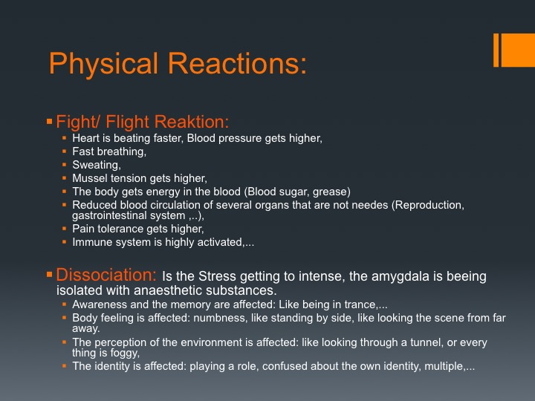
Second lesson to learn: The system of prostitution profits from the phenomenon of dissociation, in which women aren’t in a position to defend themselves. They make their bodies available and suffer extreme violence. These women become more and more traumatized.
The phenomenon of dissociation isn’t something that you can turn on and off as you wish. The dissociation can remain. There are integrative functions that can be extinguished for extended periods of time. It’s impressive to me every time I see these women reconnect with life. After successful therapy, some say: “Now I can feel pain” or “I can smell now and food has a taste” or “I understand who I am now.”
If it were just the phenomenon of dissociation, the damages from prostitution would be limited to that level, but there are also traumatic memories. During dissociation, the body and the cortex are largely anesthetized. One perceives things, but they aren’t all remembered in the cortex. Because the hyppocampus is not working properly during trauma, the information and the contextualisation of the incidents can not be stored properly. So victims of trauma are not always able to say: “this happened to me at that time, at that place.” There can be amnesia too, holes in the memory. Parts of the experience is recorded in another part of the brain, which we call “traumatic memory.” (A part of the amygdale.)

I will show you 2 pictures of the brains of a couple who were victims in a severe car accident. They were put into a computer tomograph and somebody read the story of the accident.

- Here is the reaction of the man, he reacts with fight/flight.
- The woman dissociates:
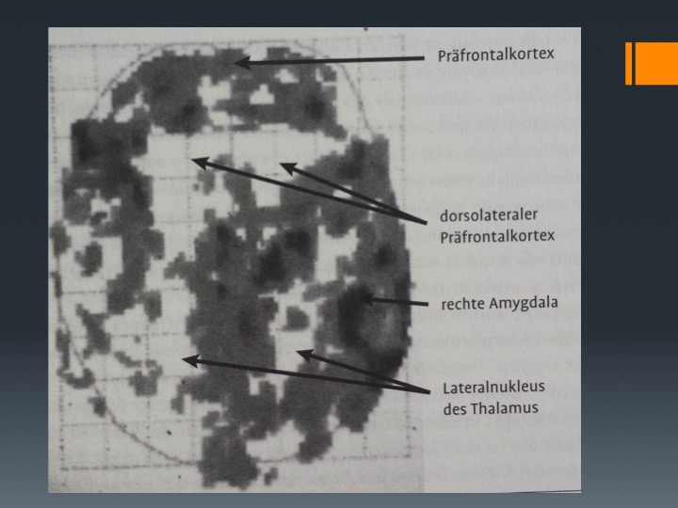
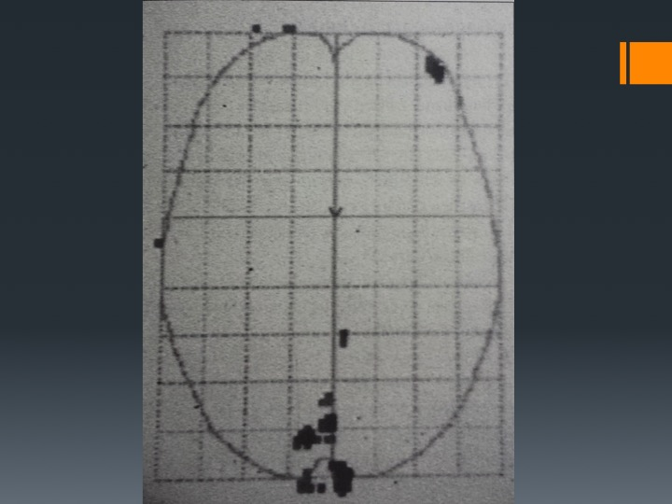

This was an experiment done by Van der Kolk, and he asked himself, why one person reacted like this, and the other one with dissociation. When he talked to the woman, he realized that she had been a victim of neglect in her childhood. So she had learned very early to switch off.

That means that the traumatic memory is full of information that puts the amygdala on fire every time it is triggered. It puts you in a condition to react with fight/flight or dissociation. This explains the high rate of re-victimization among the victims. They have learned to freeze as soon they get triggered. They can not defend or protect themselves anymore.

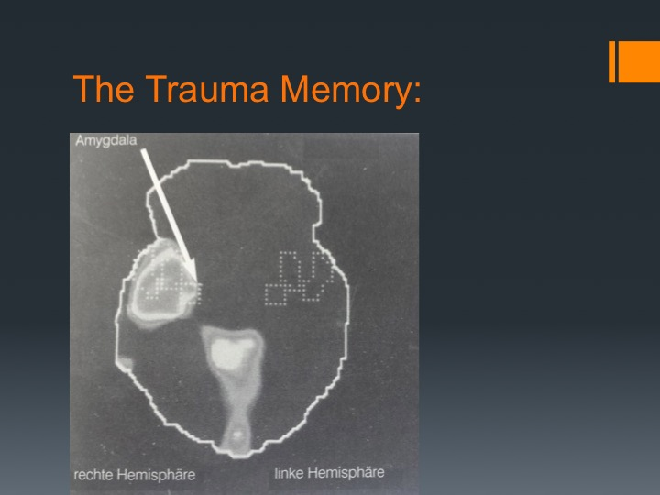
Just a couple of words about the traumatic memory: This memory doesn’t function under the same principals as the cortex. It’s a kind of black box to which we don’t have conscious access and we don’t even know that it exists. This memory collects traumatic experiences in a disorderly way, without a sense of space and time. It isn’t semantic; it doesn’t have language. It can be brought on at any moment by “trigger” events that revive the trauma: a smell, a color, a sound, images, words, phrases, etc. At that moment, it triggers an intense anxiety, as if the person was reliving the trauma at that very instant. It’s what they call a “flashback.” These reactions are known as PTSD: post-traumatic stress disorder. It´s like having a time bomb in the head.

Here I have listed the symptoms of PTSD: Trauma is a fear reaction. The body continues to feel as if the trauma is happening again all the time, and again, and again. The brain is being damaged and makes us think that the danger is still there, that it is not gone.
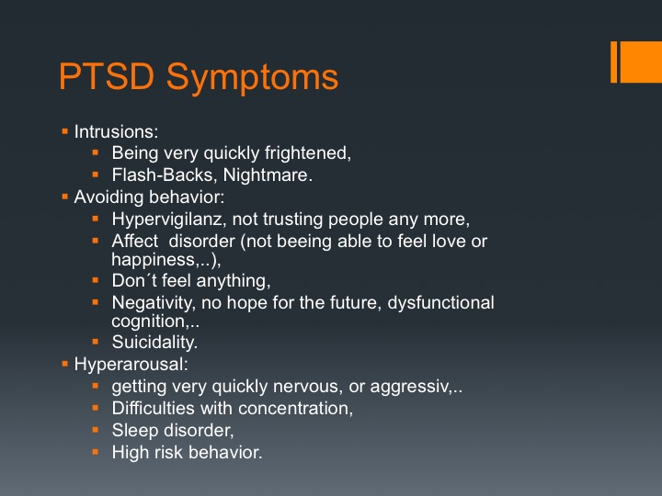

So this is a simple PTSD, a person who has been victim of a trauma Typ I, like the victim of 9/11.

What happens now if somebody is repeatedly exposed to traumatic abuse? And it´s actually heard by people who should care? You can imagine that our alarm system is totally disregulated and our capacity to calm down and to feel safe has not been developed. Many studies over PTSD have realized a high comorbidity with other mental disorders.

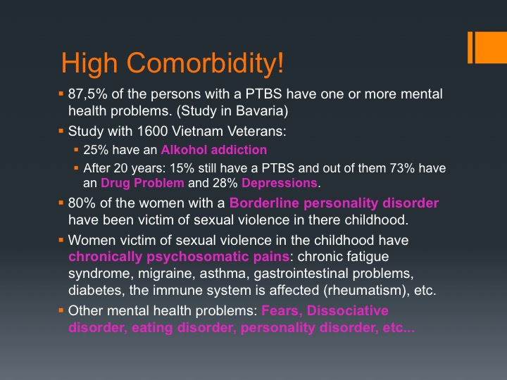

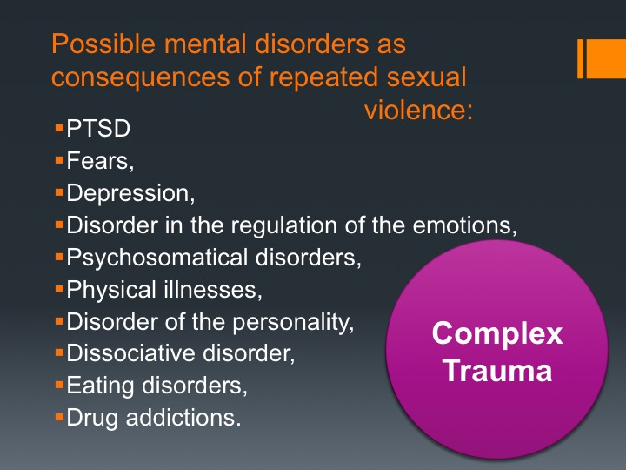
Victims of interpersonal and chronical abuse are under constant distress. There was no safe place, no safe person for them. They don´t know what that means. Those children also develop a sense of self in this environment. Those who should help hurt. So the self is doused in abandonment, deception, blame, humiliation and isolation. The child develops a deep sense of shame, because they think that it´s their fault that this has happened.

Those people, when they become adults, meet many diagnostic criteria. But perhaps they have only one. It´s complex trauma.

For more than 30 years experts in trauma have wanted to have this new diagnosis to be accepted in the classification system. It was refused in '94 when the DSM4 came out, and again refused in 2013 for the DSM5. Van der Kolk says that we have an insane diagnostic system that ignores people's lives. It is just classifying people into diagnoses by describing symptoms but does not identify what people actually suffer from. So again: keep silent.

- People with complex trauma have difficulties regulating their emotions and impulses. They tend to overreact to stress. They have difficulties to calm themselves down, because they didn´t learn it. They become self-destructive, because external pain is easier to support than inside pain: eating disorders, self harm, addictions, prostitution,..
- They often have dissociative symptoms. The information and experiences are not narrative. They can not talk about what happened to them, because the memory is not integrated. It continues to impact their life, but it can not be spoken. There are no files in the brain of those persons where they can say what happened to them. Their memory is fragmented. The only way to get away, if you can not flee physically, it´s to go away with your mind: you dissociate. They haven't learned to protect themselves, to defend themselves. That's why re-victimization happens so often. One of the strongest forms of dissociation is to develop a multiple personality.
- The way they perceive themselves gets destroyed. They have perpetrator introjections: they think that they are unlovable, incapable, undesirable. Victims blame themselves and believe that nobody will understand. They carry a great sense of shame. Not just about what was done to them, but thinking that it was done to them because of who they are.
- Changes in the perception of the perpetrator: they constantly think of the perpetrator, they feel controlled by him even if he is not there anymore, they take the perpetrator's view of themselves, they attribute total power to the abuser. They bond to their abuser because bonding is necessary for the child to grow up. Very often the abuser is also a nice person. Many trafficked victim call their pimps daddy.
- They have no model in their minds of what a healthy relationship looks like. You can´t do what you have never seen. So very often they get the diagnosis of a personality disorder called borderline.
- Chronic trauma affects the body also. They suffer of somatization.

So in therapy we give them the skills to self-management. We put words on that what was hidden, we uncover the lies. We cry. We show them that a different kind of relationship is possible.

The dynamic of prostitution and trauma is “you have no choice”. Understanding what happened and has been done with one's self opens a door and lets one say: “I have the choice”.

Thank you!

Dr. Ingeborg Kraus
Psychologist and expert in psychotraumatology
Initiator of the appeal “German psychologists and the scientific case against prostitution“

http://www.trauma-and-prostitution.eu/
Amalienstr. 47 - 76133 Karlsruhe – Germany

Bibliographie:

http://www.ceasenow.org/
Bessel Van Der Kolk: Verkörperter Schrecken. (The body keeps the score). Probst Verlag, 2016.
https://karlsruherappell.com/der-appell/
http://www.trauma-and-prostitution.eu/en/the-appeal/
https://www.change.org/p/punish-the-buying-of-sex-abolish-prostitution
https://stopsexkaufdotorg.files.wordpress.com/2015/03/lettertochancellorangelamerkel-2.pdf
Posttraumatische Belastungsstörung. Leitlinie und Quellentext. 2. Auflage. Schattauer. P. 4.
WHO: Global status report on violence prevention. http://www.who.int/violence_injury_prevention/violence/status_report/2014/en/
Association mémoire traumatique et victimologie: Impact des violences sexuelles de l´enfance à l´âge adulte. Mars 2015. http://www.memoiretraumatique.org/assets/files/doc_violences_sex/Rapport-enquete-AMTV_mars-2015_BD.pdf
Study done by Schröttle & Müller 2004 in: Bundesministerium für Familie, Senioren, Frauen und Jugend : Gender Datenreport », Kapitel 10: Gewalthandlungen und Gewaltbetroffenheit von Frauen und Männern, P. 651-652, 2004.
http://www.traummaennlein.de/
Michaela Huber, Trauma und Prostitution aus traumatherapeutischer Sicht, 2014: http://www.michaela-huber.com/files/vortraege2014/trauma-und-prostitution-aus-traumatherapeutischer-sicht.pdf
- Study by Melissa Farley: Prostitution and trafficking in 9 countries, 2004. http://www.trauma-and-prostitution.eu/en/2015/01/26/prostitution-and-trafficking-in-nine-countries-an-update-on-violence-and-posttraumatic-stress-disorder/ - Study done by Schröttle & Müller 2004 in: Bundesministerium für Familie, Senioren, Frauen und Jugend : Gender Datenreport », Kapitel 10: Gewalthandlungen und Gewaltbetroffenheit von Frauen und Männern, P. 651-652, 2004. - Study by Zumbeck in Germany in 2001, Zumbeck, Sibylle: Die Prävalenz traumatischer Erfahrungen, Posttraumatische Belastungsstörungen und Dissoziation bei Prostituierten , Hamburg, 2001.
- Study by Melissa Farley from 2008 that found that 68% of the women in prostitution experienced PTSD at a similar intensity to combattant veterans or people who survived torture. http://www.trauma-and-prostitution.eu/en/2015/01/26/prostitution-and-trafficking-in-nine-countries-an-update-on-violence-and-posttraumatic-stress-disorder/ - Study by Zumbeck in Germany in 2001, who found that 60% suffered from intense PTSD. Zumbeck, Sibylle: Die Prävalenz traumatischer Erfahrungen, Posttraumatische Belastungsstörungen und Dissoziation bei Prostituierten , Hamburg, 2001.
Dr. Rebecca Campbell: The Neurobiologie of Trauma. 2015. This video is not available any more: https://www.youtube.com/watch?v=mTOZE90-fCY
Bessel Van Der Kolk: Verkörperter Schrecken. (The body keeps the score). Probst Verlag, 2016, P. 85
Hans Morschitzky: Angststörungen. Springer Verlag, 4. Auflage, 2009. Kapitel: Epidemiologie, Verlauf und Folgen der posttraumatischen Belastungsstörung, P. 139-145.
Wolfgang Wöller: Trauma und Persönlichkeitsstörungen. Schattauer, 2006, Kapitel 10: Symptomdiagnostik, P.111-122.
Diane Landberg: Complex Trauma: Understanding and Treatment. 21.01.2016. https://www.youtube.com/watch?v=otxAuHG9hKo

